Security Recommendations for PC Desktop and Laptop Computers

Recommendations for protecting data stored on Desktop and Laptop Computers

Whenever possible, confidential or sensitive data should NOT be saved on the hard disks of desktop and laptop computers.

Confidential or sensitive data can include any personal information (yours or anyone else’s) that is not public knowledge. Particular caution must be taken with items such as social security numbers, credit card numbers, student grades, salary information, etc.

Guidelines:

- Whenever possible, store files on the file server Dragon.
Not only is data stored on the file server backed up nightly, sharable with your colleagues and accessible from different computers, but the security settings can be customized to allow or disallow access to any folder or file stored there.

You have several options for storing data on Dragon:

  - H Drive: This is your Home Directory which is your private storage area. Only you and the system administrator can access it.

  - G Drive: This is a shared data folder which members of your department can access. More folders can be created within this folder and security can be customized to control who can read, write or share data there. You can work with your Desktop Support Specialist to tailor this security to your and your department’s needs.

  - Special shares: Additional shared folders can also be created with unique security settings when needed.

- Do not store any data that is not essential on your C: drive or other internal hard disk.
If you will be taking your laptop off campus, bring only that data which you absolutely need and cannot retrieve via the Internet.

- Whenever your computer asks if you would like a password saved, always respond ‘no’.
Passwords are to ensure that only you have access to those systems, programs or files. If your computer is stolen or used by an unauthorized individual, they will have complete access to your data.

- Set a Screen Saver password.
If your computer is not in a secure location or if you are called away from your desk for a period of time, this prevents someone from using it or viewing anything confidential that might be on your screen.

Instructions for setting a screen saver password:
- Right Click anywhere on your desktop (not on an icon or tool bar)
- Select Properties
- Click on the Screen Saver tab

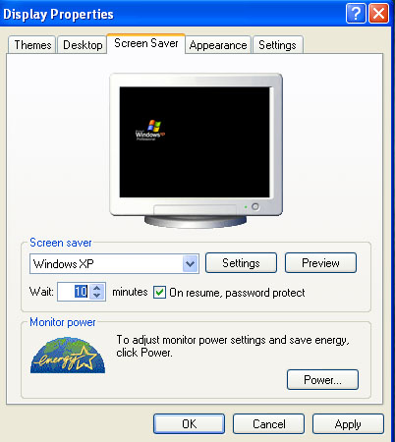

- Select one of the available Screen savers from the drop-down menu.
- Indicate the desired Wait period. If your computer is inactive for this length of time, the screen saver will be displayed.
- Click on ‘On resume, password protect’
- Click on OK

- Password Protect individual documents. If a document contains particularly sensitive data, Password Protect it.

Warning: You are the only one who will know this password, so use this feature with caution. No one else will be able to retrieve this document!

Instructions for Password Protecting a Microsoft Word document
  - From the Word menus, Click on Tools and select Options
  - From the Options dialog box, click on the Security tab

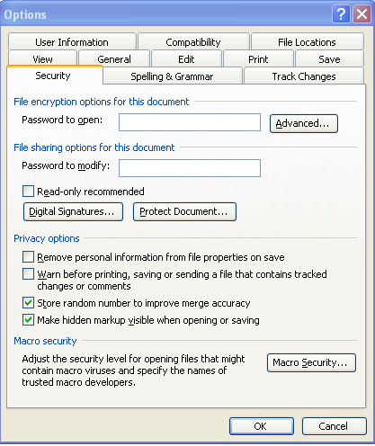

- Type in the password that you want to use to open this document
- You can use other options on this screen to further fine-tune the security features
- Click OK when done

