Security Recommendations for Desktop and Laptop Computers

Macintosh 10.4 version

Recommendations for protecting data stored on Desktop and Laptop Computers

Whenever possible, confidential or sensitive data should NOT be saved on the hard disks of desktop and laptop computers.

Confidential or sensitive data can include any personal information (yours or anyone else’s) that is not public knowledge. Particular caution must be taken with items such as social security numbers, credit card numbers, student grades, salary information, etc.

Guidelines:

- Whenever possible, store files on the file server Dragon.
Not only is data stored on the file server backed up nightly, sharable with your colleagues and accessible from different computers, but the security settings can be customized to allow or disallow access to any folder or file stored there.

Connect to Dragon by choosing Connect To Server from the Go menu. Enter dragon.wesleyan.edu in the connect box. Once you login, you have several options for storing data on Dragon:

  - DepartmentHome (i.e. ENGLHome): This is your Home Directory which is your private storage area. Only you and the system administrator can access it.

  - DepartmentData (i.e. ENGLData): This is a shared data folder that all members of your department can access. More folders can be created within this folder and security can be customized to control who can read, write or share data there. You can work with your Desktop Support Specialist to tailor this security to your and your department’s needs.

  - Special shares: Additional shared folders can also be created with unique security settings when needed.

- Do not store any data that is not essential on your computer drive or other internal hard disk.
If you will be taking your laptop off campus, bring only that data which you absolutely need and cannot retrieve via the Internet.

- Whenever your computer asks if you would like a password saved, always respond ‘no’.
Passwords are to ensure that only you have access to those systems, programs or files. If your computer is stolen or used by an unauthorized individual, they will have complete access to your data.

- Set a Screen Saver password.
If your computer is not in a secure location or if you are called away from your desk for a period of time, this prevents someone from using it or viewing anything confidential that might be on your screen.

Instructions for setting a screen saver password:
- From the Apple menu on the top left of the screen, choose System Preferences.
- Select Security
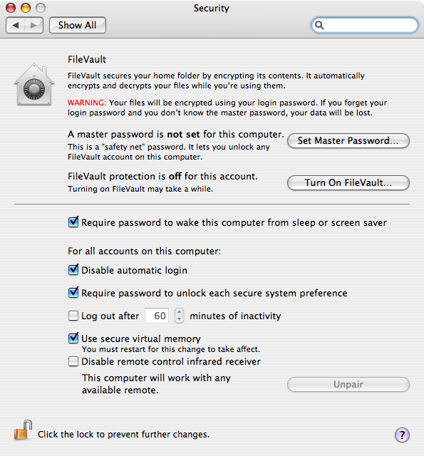

- Require password to wake this computer from sleep or screen saver: When the screen saver is active, you’ll be asked to enter your computer name and password before continuing.
- Disable automatic login: When the computer boots up, you’ll need to enter your login name and password before continuing.
- Require password to unlock each secure system preference: To check System Preference settings, you’ll need to enter your name and password
- Log out after X minutes of inactivity: This checkbox will log you out if you have been inactive on the computer. This may cause problems if you have documents open and not saved.
- Use secure virtual memory: Some passwords may be saved in RAM. While very difficult to get those passwords, it may be possible. Checking this box makes it near impossible.
- Disable remote control infrared receiver: disables the remote control that comes with new computers. There may be unknown security risks with the remote port. If you are not using the remote, check this box.

- Close the window using the red button to save the settings.

- Disable Bluetooth. Bluetooth is a wireless network language for the computer to talk to local devices like cell phones, palm-pilots, and other PDAs. Some minor security risks have been associated with Bluetooth.
  - From the Apple Menu, choose System Preferences
  - Select the icon for Bluetooth
  - If you are not using Bluetooth, click the button “Turn Bluetooth Off”
  - If you are using Bluetooth, uncheck the box labeled “Discoverable”
NOTE: If you are not sure, then you are most likely NOT using Bluetooth.

- Password Protect individual documents. If a document contains particularly sensitive data, Password Protect it.

Warning: You are the only one who will know this password, so use this feature with caution. No one else will be able to retrieve this document!

Instructions for Password Protecting a Microsoft Word document
  - From the Word menus, Click Preferences
  - From the bar on the left, choose Security

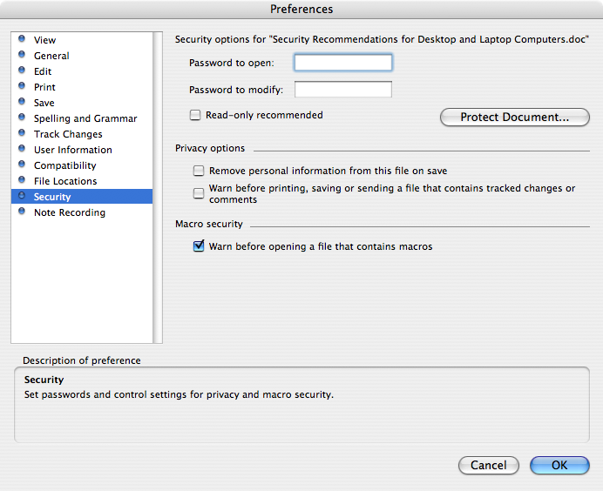

- Type in the password that you want to use to open this document.
- You can use other options on this screen to further fine-tune the security features.
- Click OK when done.

- Use FileVault to encrypt all data. All of your personal data on your computer should be kept in your personal space on your computer by default. If you enable FileVault, that data can be encrypted when you log out. This prevents anyone from accessing that data – even if they start from another disk or reset your password.
WARNING: If the FileVault password is lost, data cannot be recovered. Also, backups may not run if FileVault is enabled. Finally, if there is a hard drive problem on the computer, FileVault may prevent data from being recovered.

- To Enable FileVault, From the Apple Menu, choose System Preferences.
- Select Security.
- Set a Master Password if one has not been set. A master password will allow you to reset the account password, but WILL NOT allow access to the documents on the computer.
- Click the button “Turn On FileVault”.
- When you log out (from the Apple Menu choose Log Out), your data will be encrypted.

Todd Houle
16Dec06

